**THE REQUIREMENTS OF THE PROJECT ARE AS FOLLOWS:**

* AZURE BOARD WITH FULL EXPANSION ON USER STORIES, USE CASES AND TASKS NEEDED TO COMPLETE THE PROJECT. IT COULD ALSO PROVIDE A RECORD OF ANY ISSUES OR RISKS THAT YOU FACED

Microsoft Azure board is a**tool used for managing the work for software development** and this tool is mainly used in Azure DevOps which helps to plan the work and daily activities for the team.

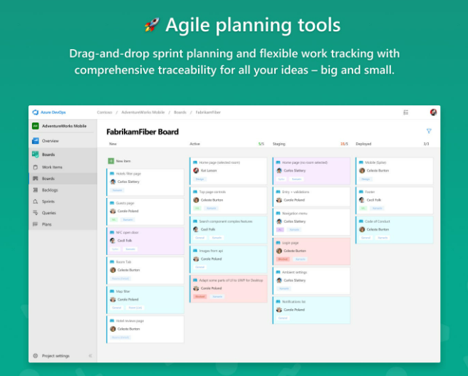

User stories are a few sentences in simple language that outline the desired outcome. They don't go into detail. Requirements are added later, once agreed upon by the team. collection of stories keeps the team focused on solving problems for real users. With the end goal defined, the team can work together to decide how best to serve the user and meet that goal. Another common step in this meeting is to score the stories based on their complexity or time to completion.

Include:

* What is our definition of done
* Define tasks: What steps need to be completed and who is responsible for each step
* Are there multiple users? Then we need multiple stories for each user persona
* Write a story for each step
* Include user feedback/issues/risks
* **“As a [persona], I [want to], [so that].”**

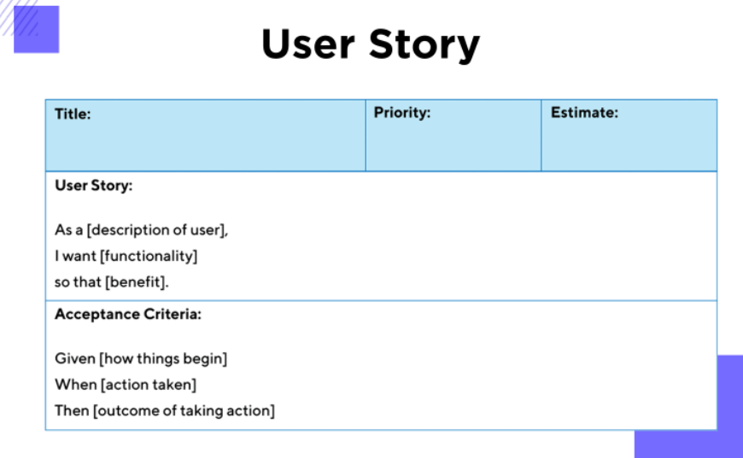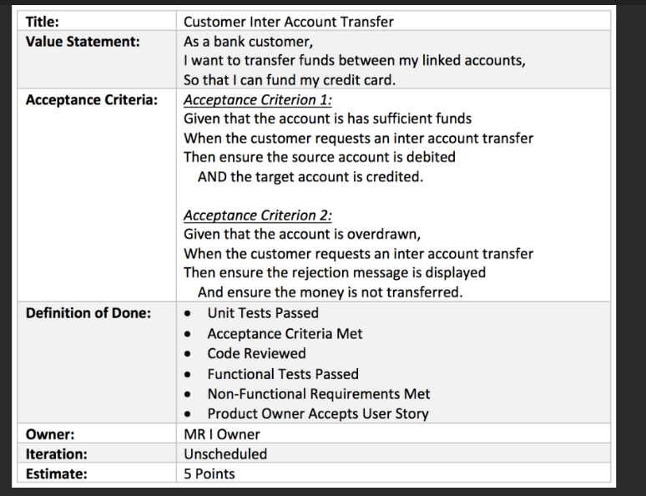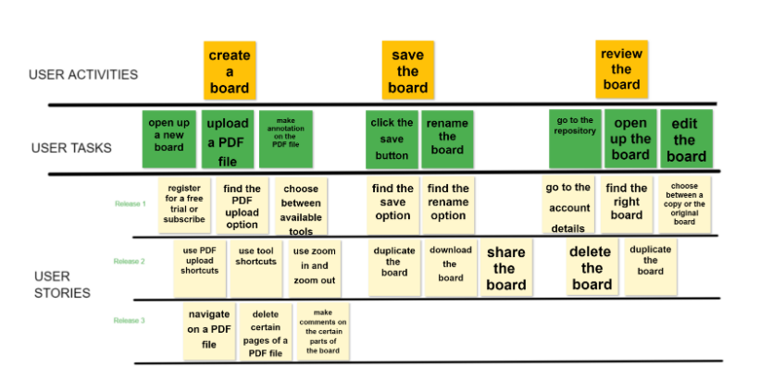

* A RELATIONAL DATABASE USED TO STORE DATA PERSISTENTLY FOR THE  
  THE PROJECT, THIS DATABASE NEEDS TO HAVE AT LEAST 2 TABLES IN IT, TO  
  DEMONSTRATE YOUR UNDERSTANDING.

DO THIS IN **SQL**. A relational database is a type of database that stores and provides access to data points that are related to one another. In a relational database, each row in the table is a record with a unique ID called the key. The columns of the table hold attributes of the data, and each record usually has a value for each attribute, making it easy to establish the relationships among data points. The software used to store, manage, query, and retrieve data stored in a relational database is called a relational database management system (RDBMS).

**Example of two tables to process orders for its products.**

The first table is a customer info table, so each record includes a customer’s name, address, shipping and billing information, phone number, and other contact information. Each bit of information (each attribute) is in its own column, and the database assigns a unique ID (a key) to each row.

In the second table—a customer order table—each record includes the ID of the customer that placed the order, the product ordered, the quantity, the selected size and color, and so on—but not the customer’s name or contact information.

Tables have only the ID column (the key) in common so the relational database can create a relationship between the two tables. When the application submits an order to the database, the database can go to the customer order table, pull the correct information about the product order, and use the customer ID from that table to look up the customer’s billing and shipping information in the customer info table.

*\*\* relational databases follow certain integrity rules. For example, an integrity rule can specify that* ***duplicate rows are not allowed in a table*** *to eliminate the potential for erroneous information entering the database.*

*BookID BookTitle BookAuthor BookYear*

*1 Adventures of Tom Sawyer Mark Twain 1876*

*2 Alice in Wonderland Lewis Carrol 1865*

*3 Origin of Species Charles Darwin 1859*

*4 Adventures of Sherlock Holmes Arthur Conan Doyled 1892*

*5 It Stephen King 1986*

*6 To Kill a Mockingbird Harper Lee 1960*

*7 The Diary of a Young Girl Anne Frank 1952*

*8 Little Women Louisa May Alcott 1880*

*9 The Hunger Games Suzanne Collins 2008*

*10 The Secret Garden Frances Hodgson Burnett 1911*

* CLEAR DOCUMENTATION FROM A DESIGN PHASE DESCRIBING THE ARCHITECTURE  
  YOU WILL USE FOR YOUR PROJECT AS WELL AS A DETAILED RISK ASSESSMENT.

Design documentation is a **collection of documents and resources that covers all aspects of your product design**. Documentation should include information about users, product features, and project deadlines; all essential implementation details; and design decisions that your team and stakeholders have agreed on.

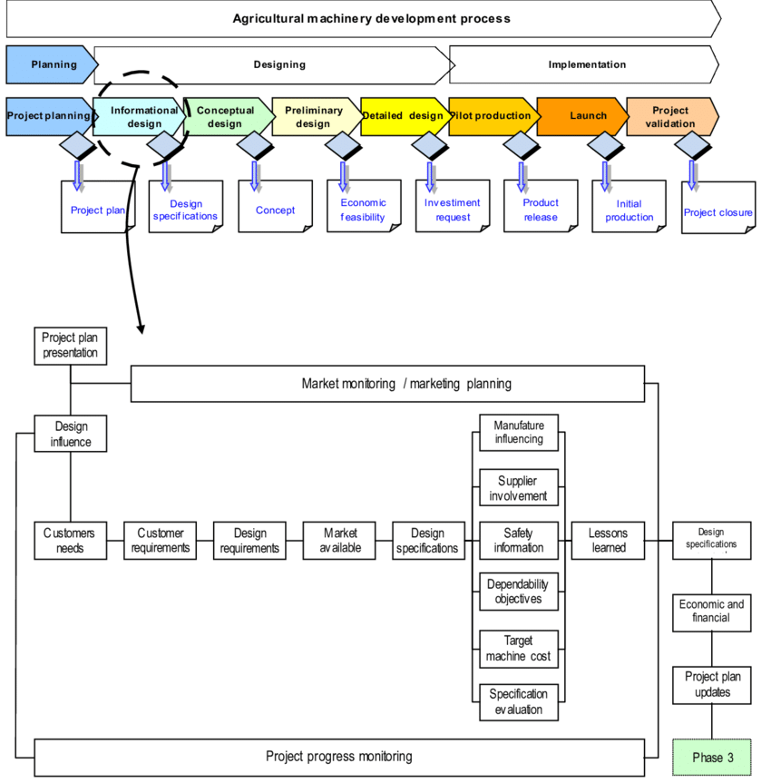

* A FUNCTIONAL CRUD APPLICATION CREATED IN C#, FOLLOWING BEST  
  PRACTICES AND DESIGN PRINCIPLES, THAT MEETS THE REQUIREMENTS SET ON  
  YOUR BOARD

Done using C#

CRUD apps are specific software applications that use the four basic functions of**Create, Read, Update and Delete** for app development.

In a REST environment, CRUD often corresponds to the HTTP methods **POST, GET, PUT, and DELETE**, ([What is CRUD? | Codecademy](https://www.codecademy.com/article/what-is-crud)) [Create Simple Web API In ASP.NET MVC (c-sharpcorner.com)](https://www.c-sharpcorner.com/article/create-simple-web-api-in-asp-net-mvc/)

STATUS CODES - 200 (OK)

* 201 (CREATED)
* 204 (NO CONTENT)
* 404 (NOT FOUND)

Create:

To create resources in a REST environment use HTTP POST method. POST creates a new resource of the specified resource type.

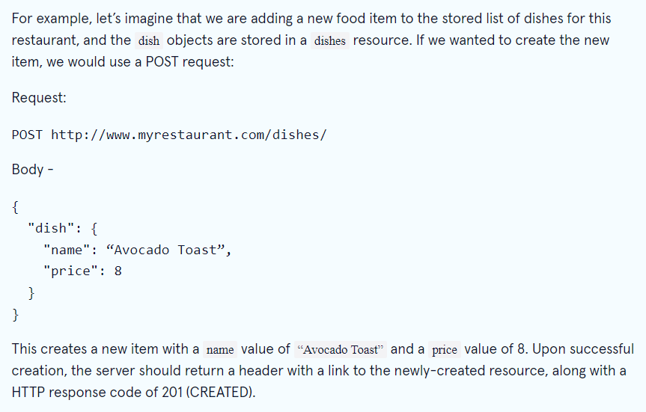

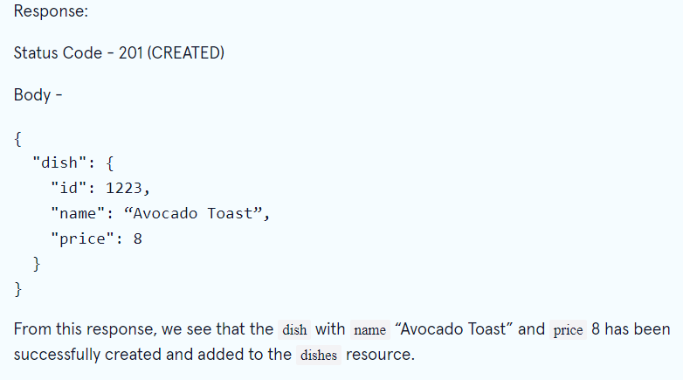

Read:

To read resources in a REST environment, we use the GET method.

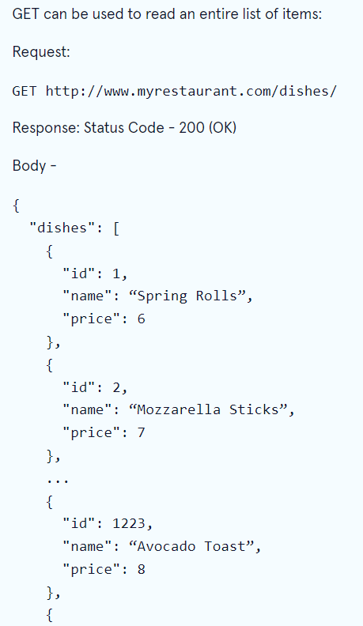

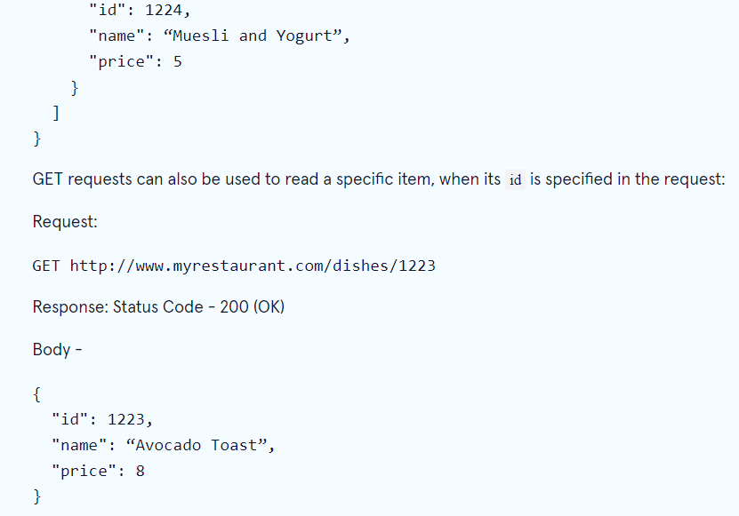 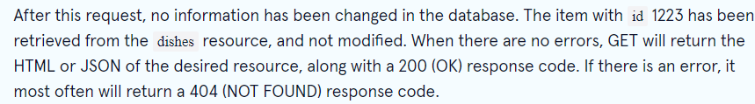

Update:

PUT is CRUD operation for update.

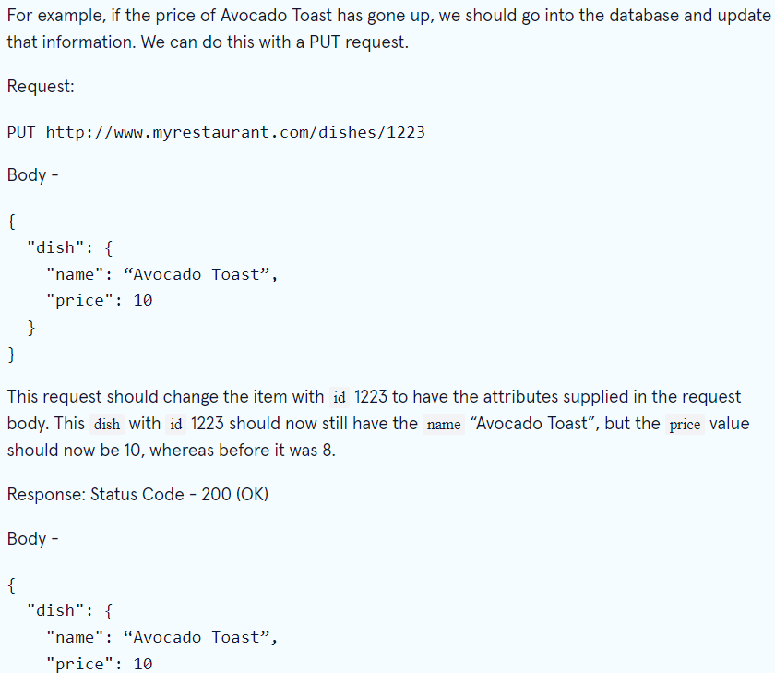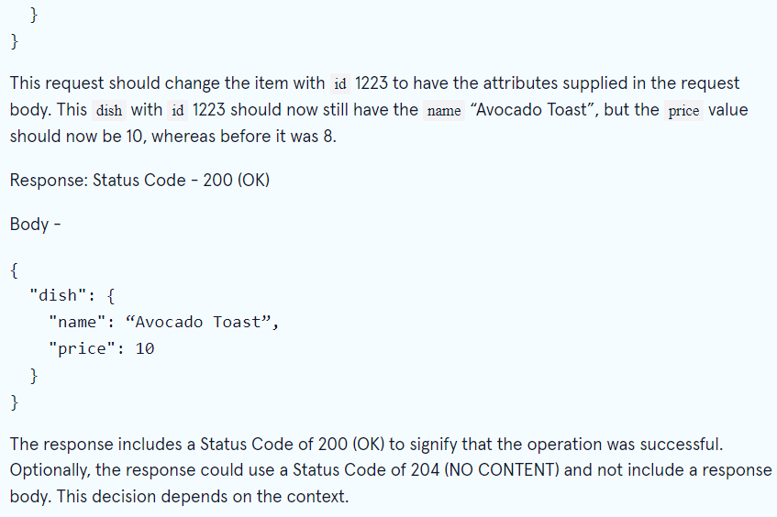

Delete:

To remove a resource from the system use Delete method.



* FULLY DESIGNED TEST SUITES FOR THE APPLICATION YOU ARE CREATING,

Create test plans and test suites to track manual testing for sprints or milestones. That way, you can see when the testing for a specific sprint or milestone is complete. You create and manage test plans and test suites from the **Test plans** hub in Azure.

[Create test plans and suites - Azure Test Plans | Microsoft Docs](https://docs.microsoft.com/en-gb/azure/devops/test/create-a-test-plan?view=azure-devops)

Within each test case, you specify a set of test steps with their expected outcomes. Optionally, you can add [shared steps](https://docs.microsoft.com/en-us/azure/devops/test/share-steps-between-test-cases?view=azure-devops) or [shared parameters](https://docs.microsoft.com/en-us/azure/devops/test/repeat-test-with-different-data?view=azure-devops). For traceability, link test cases to the user stories, features, or bugs that they test.

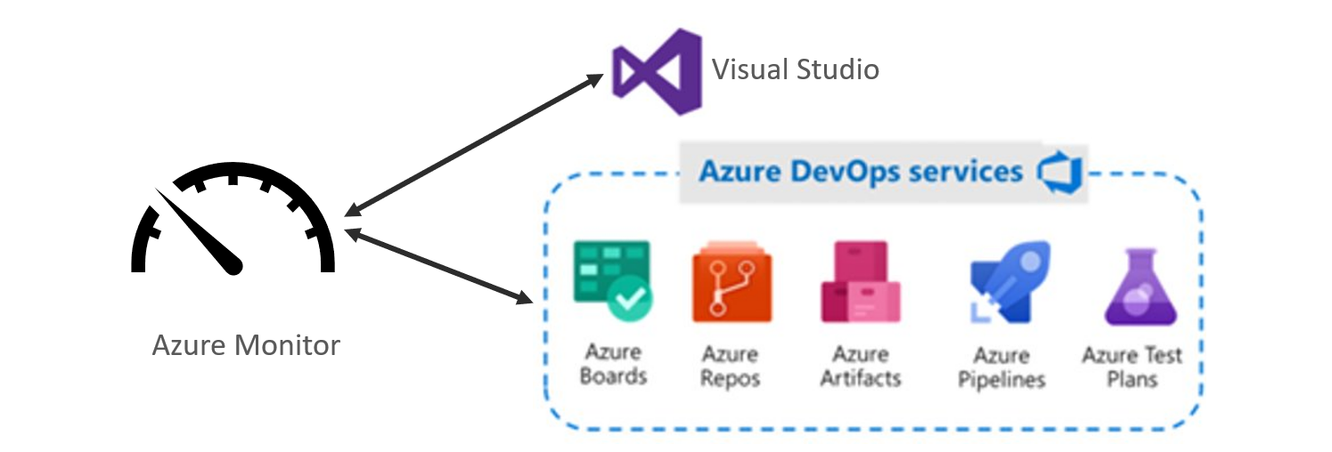

* A FUNCTIONING FRONT-END WEBSITE AND INTEGRATED WITH REST API TO YOUR APPLICATION

Using **HTML, CSS and JavaScript** to design website. Designing the interface the customer interacts with.

Good idea to create a rough layout plan before getting started.

**possible added features -the web application to be available in several languages.

Things to include:

* Front end work
* Including database architecture
* Frameworks
* Scaling solutions
* Styles: This includes the buttons, layouts, inputs, text, images.

Design requirements:

* Grid system/template layout,
* Colours/colour schemes,
* Fonts and texts
* Links and navigation
* Images / Icons,
* Forms
* Buttons
* Responsive Web Design
* **Different states of a button (Normal, hover, focused, pressed and inactive state)**
* CODE FULLY INTEGRATED INTO A VERSION CONTROL SYSTEM USING THE  
  FEATURE-BRANCH MODEL WHICH WILL SUBSEQUENTLY BE BUILT THROUGH A CI  
  SERVER AND DEPLOYED TO A CLOUD-BASED VIRTUAL MACHINE.

Using GIT, GIT BASH, Azure CLI extension

**Git software designed to record changes within one or more files over time.** It allows us to undo or to cancel all made or pending changes within one or more files. PUSH, PULL, COMMIT, UPDATE.

[GitCheatSheet_issue#2366_102019-V5 (github.com)](https://training.github.com/downloads/github-git-cheat-sheet.pdf)

[Handling Dependencies with Submodules and Subtrees - GitHub Cheatsheets](https://training.github.com/downloads/submodule-vs-subtree-cheat-sheet/)

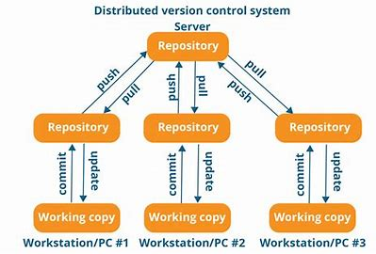 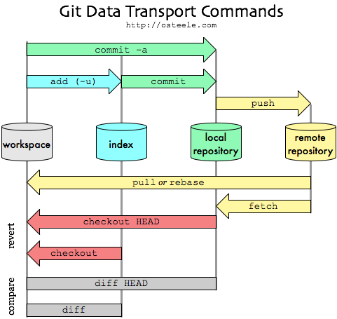

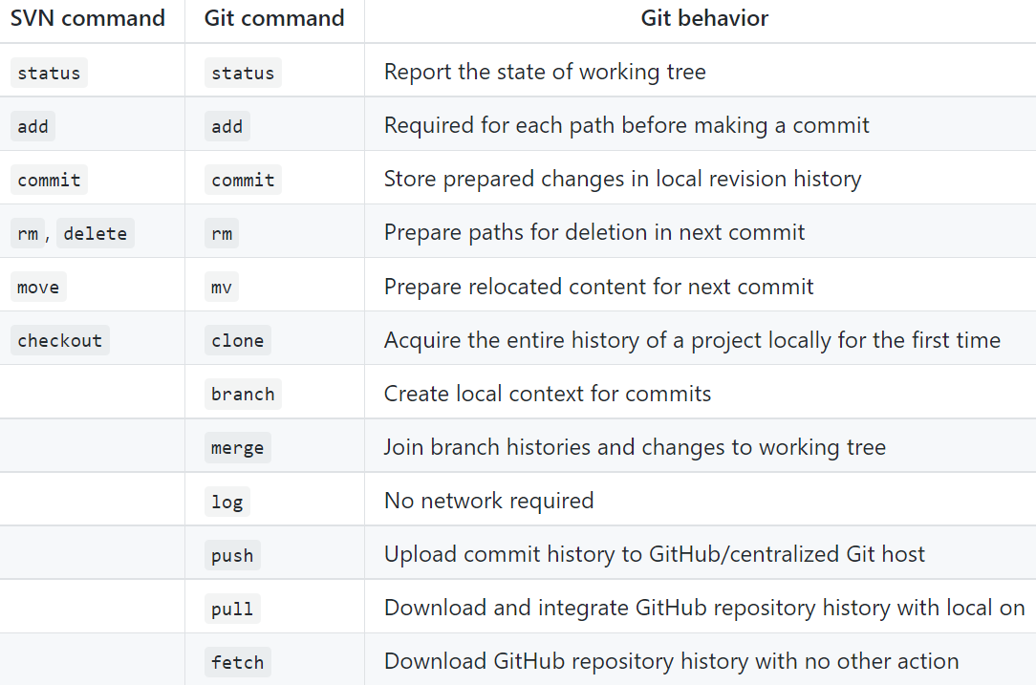

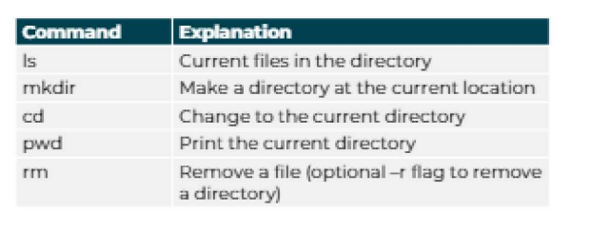

[Deploy to Azure using GitHub Actions from your favorite tools | Azure Blog and Updates | Microsoft Azure](https://azure.microsoft.com/en-gb/blog/deploy-to-azure-using-github-actions-from-your-favorite-tools/)

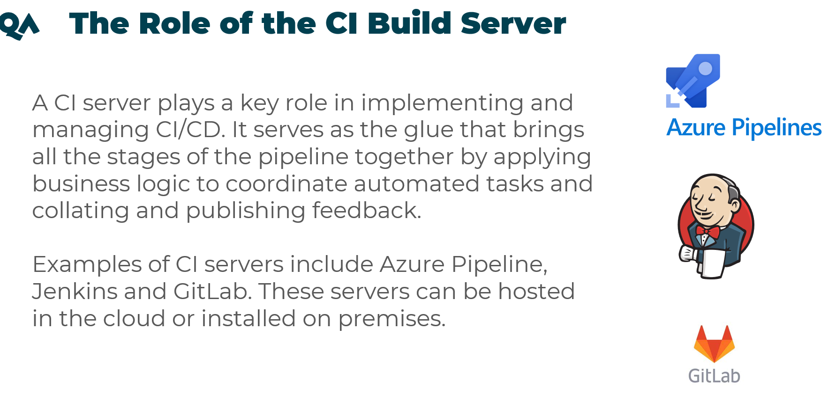

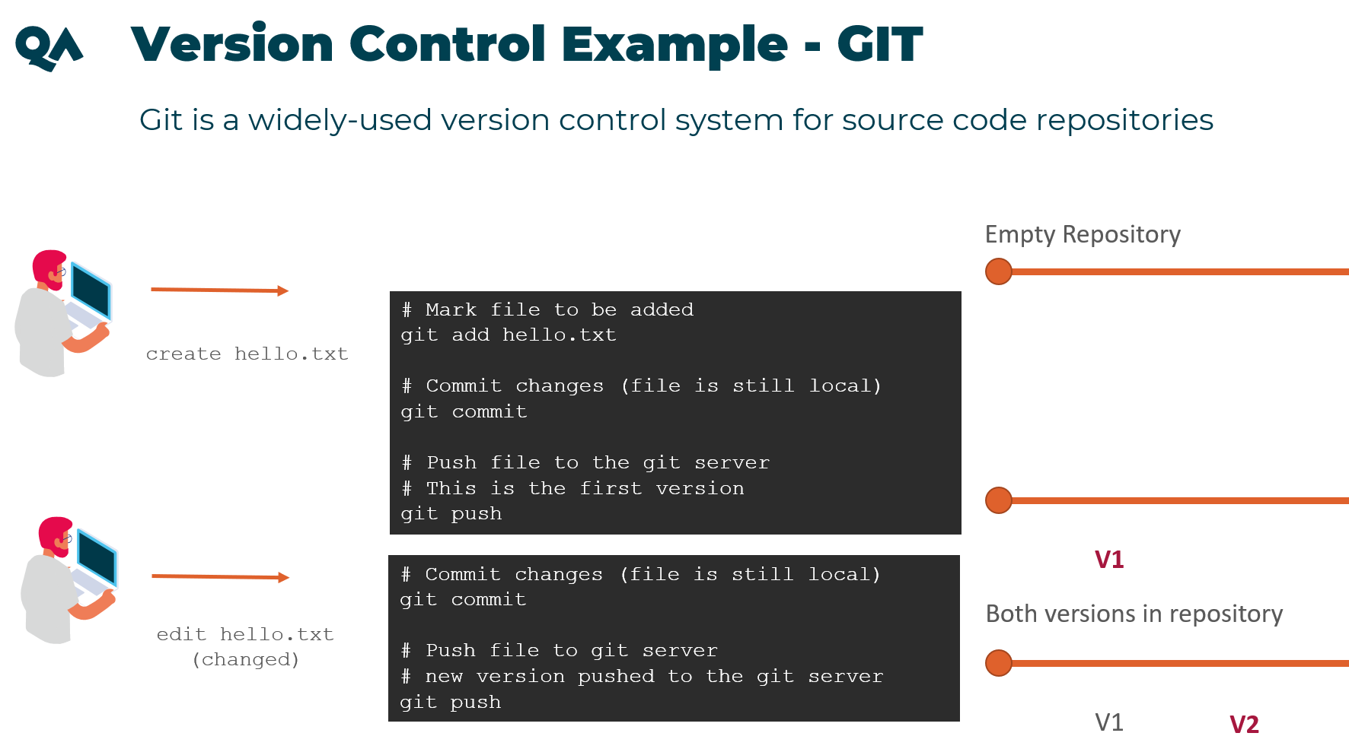

GIT:

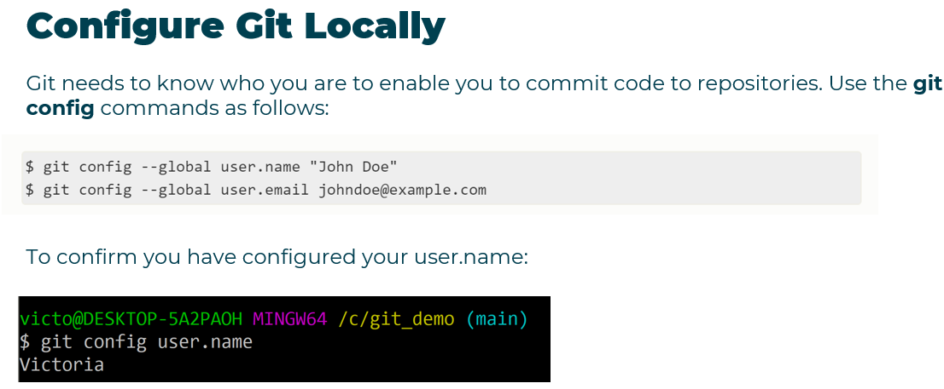

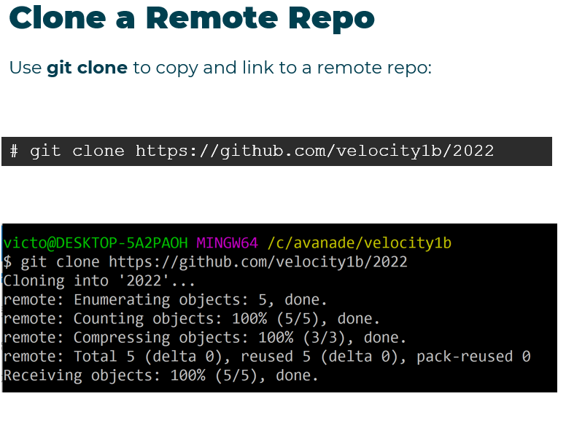

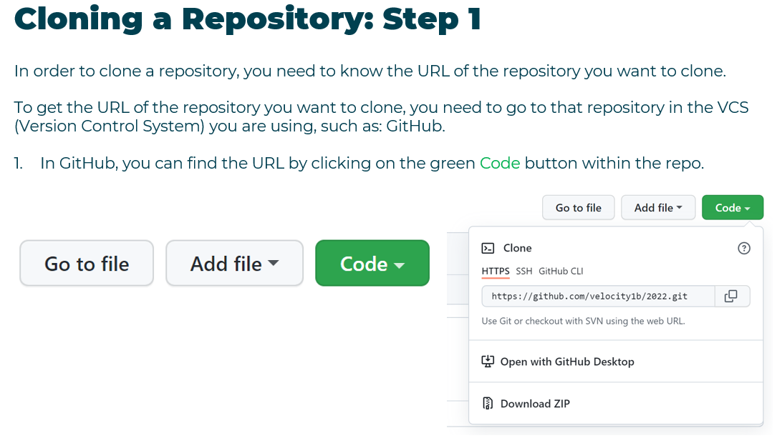

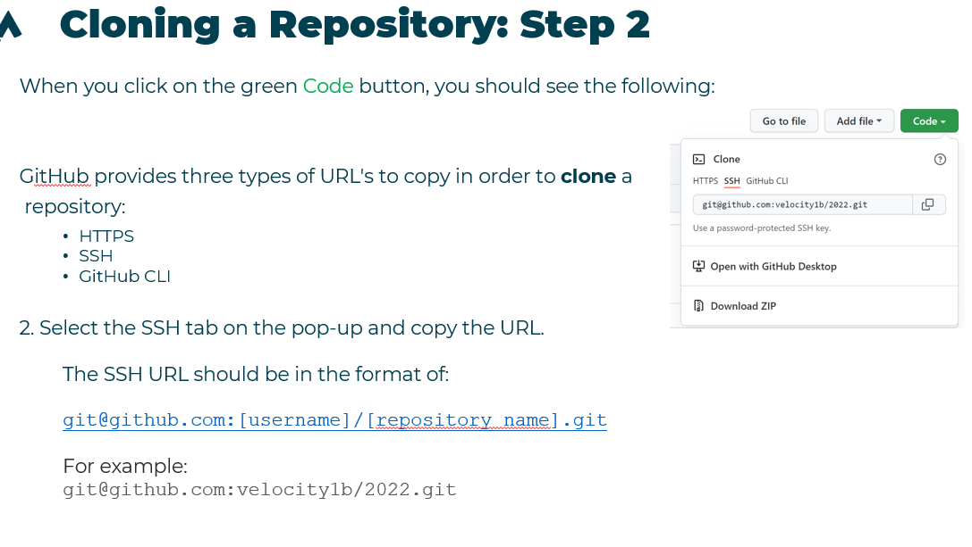

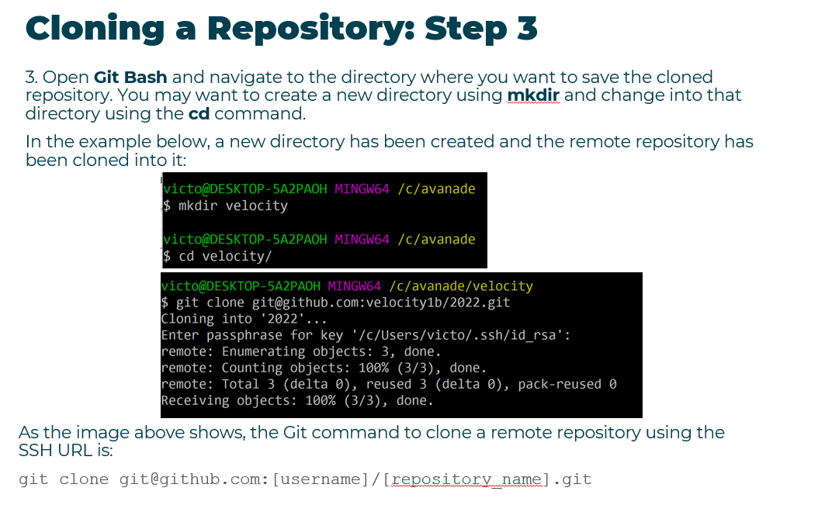

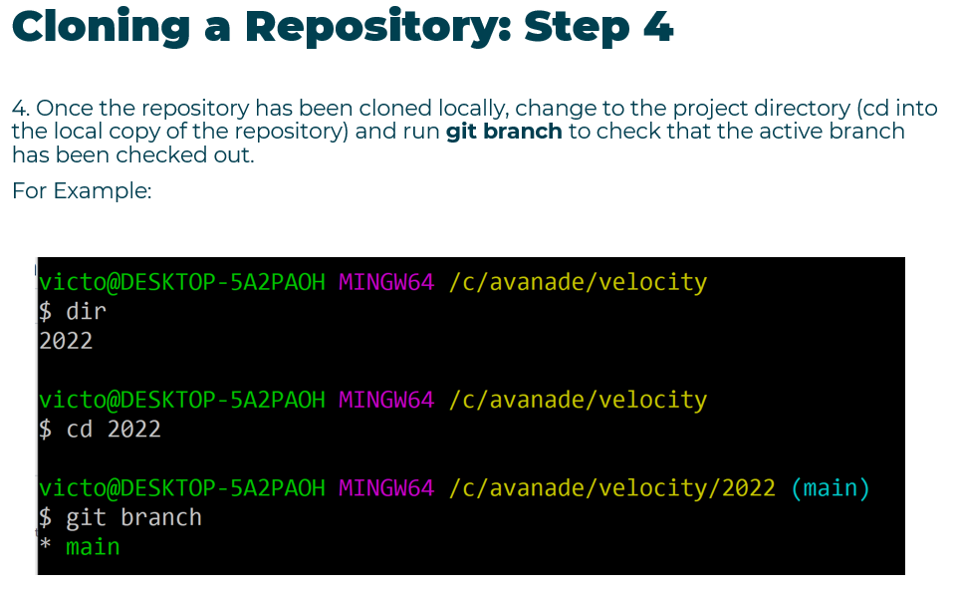

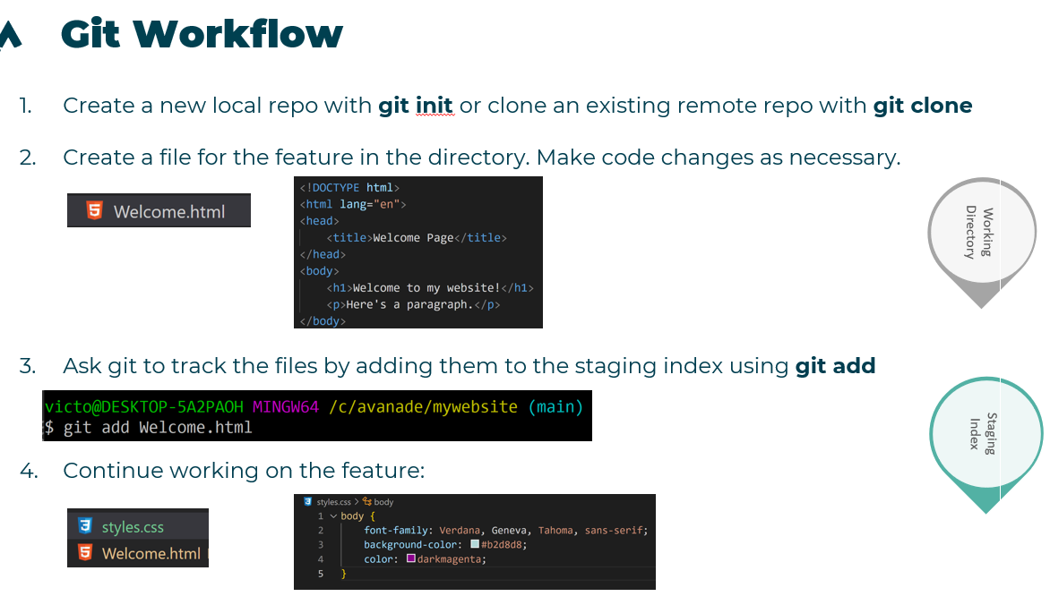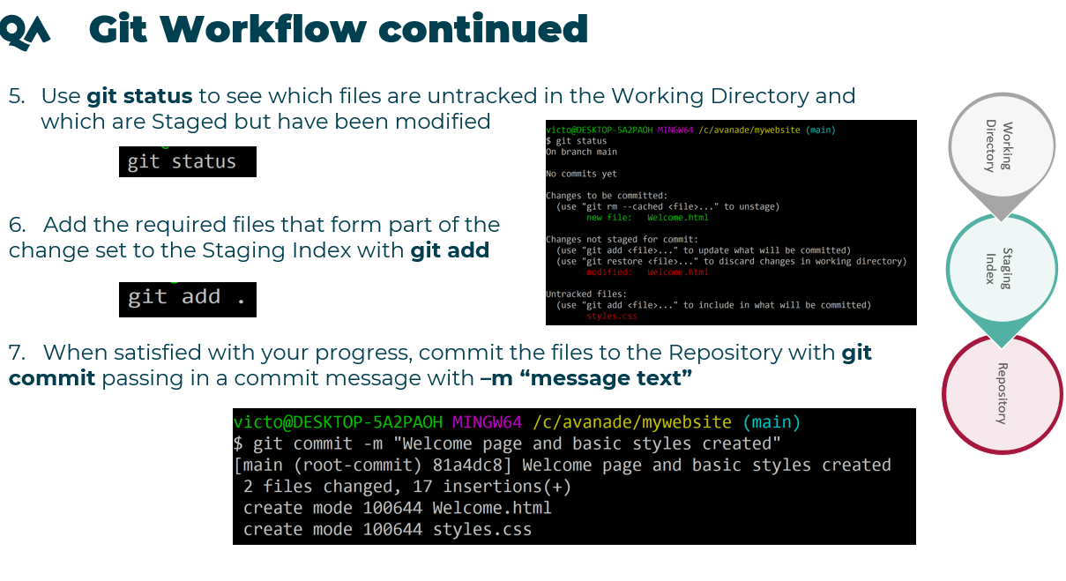

C:\C# code\MiniProject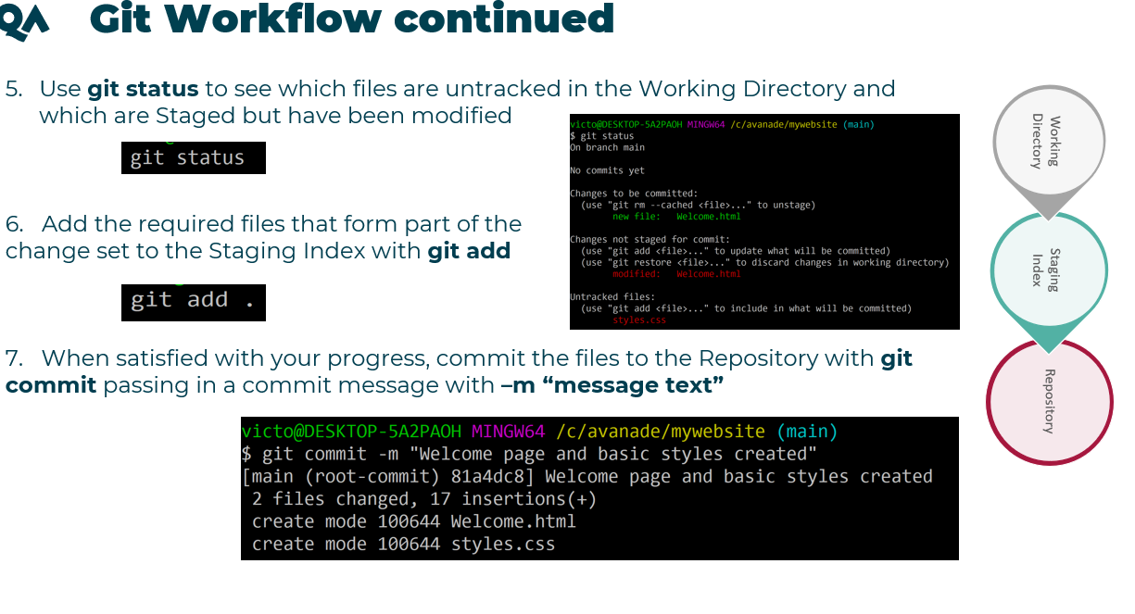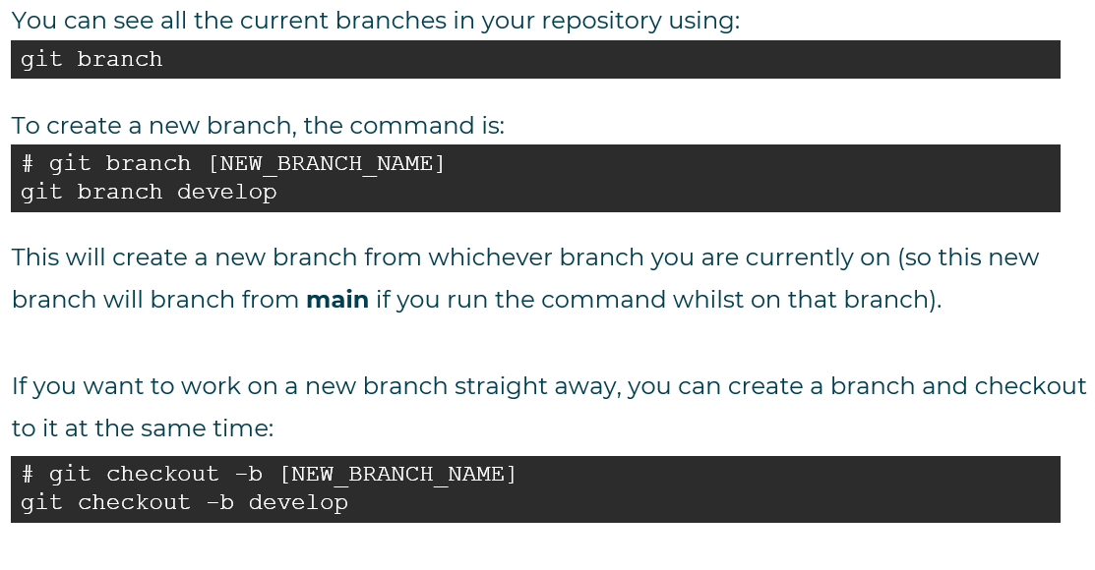

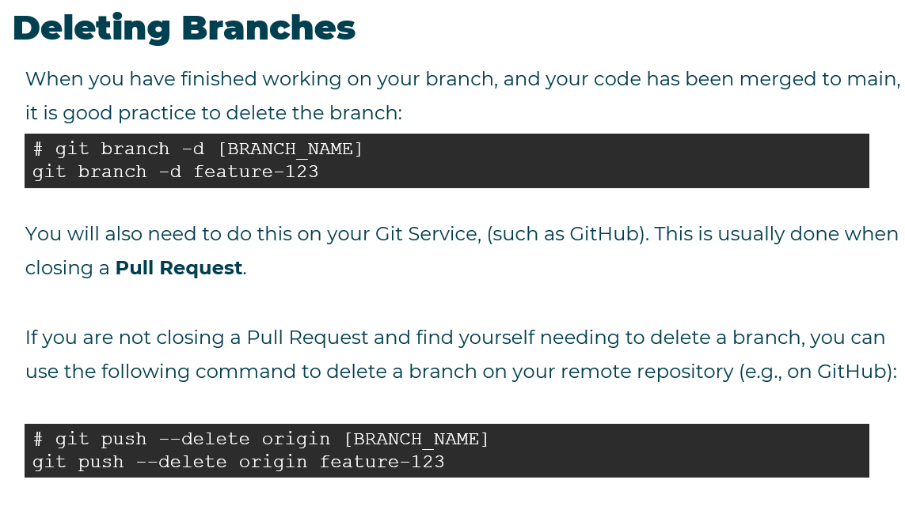

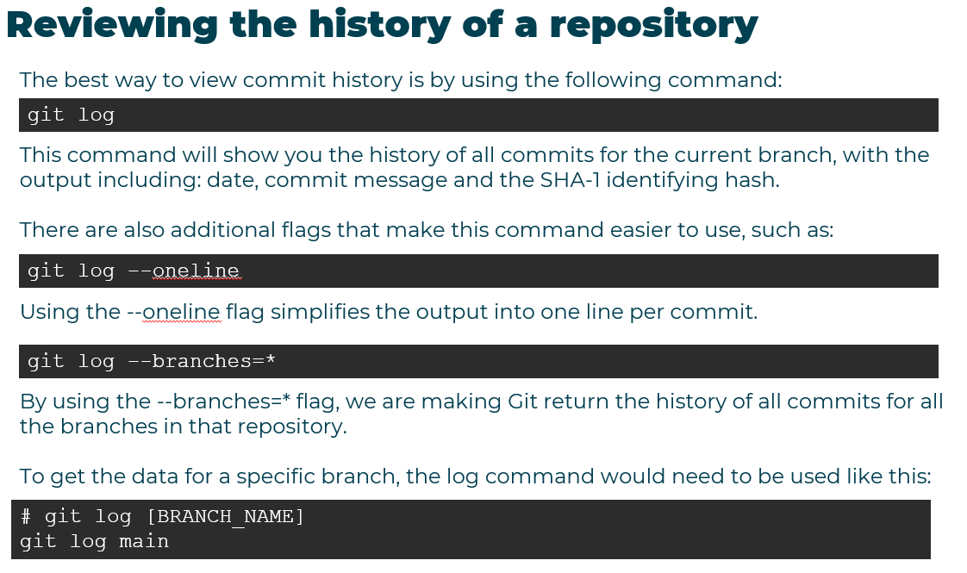

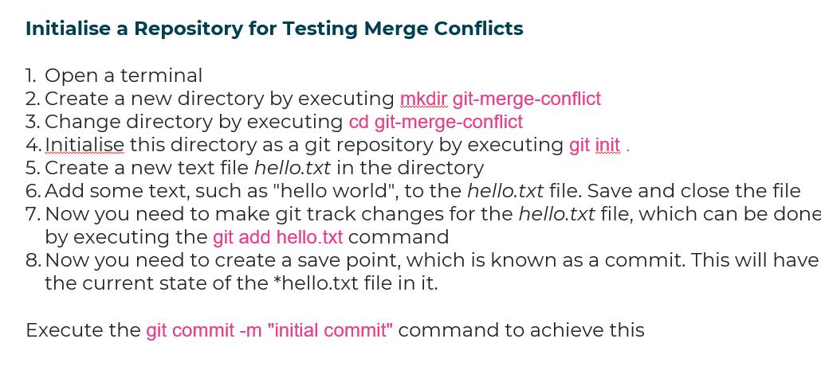

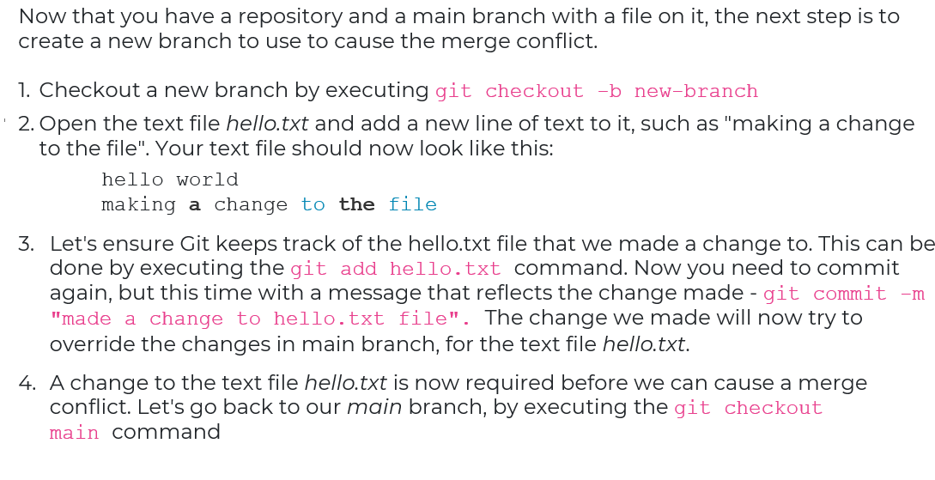

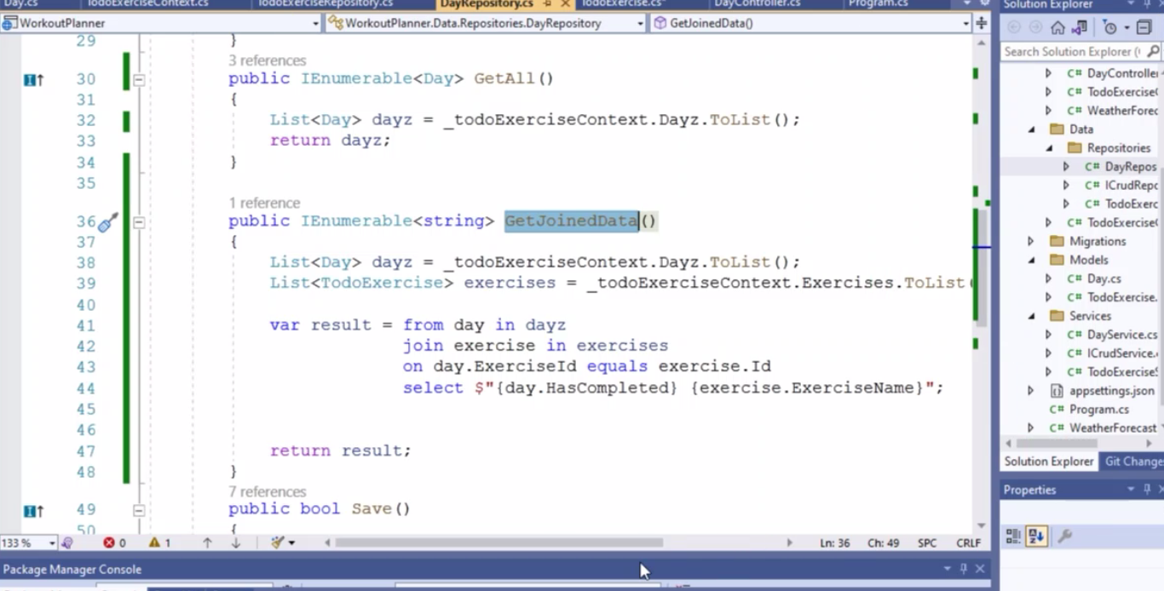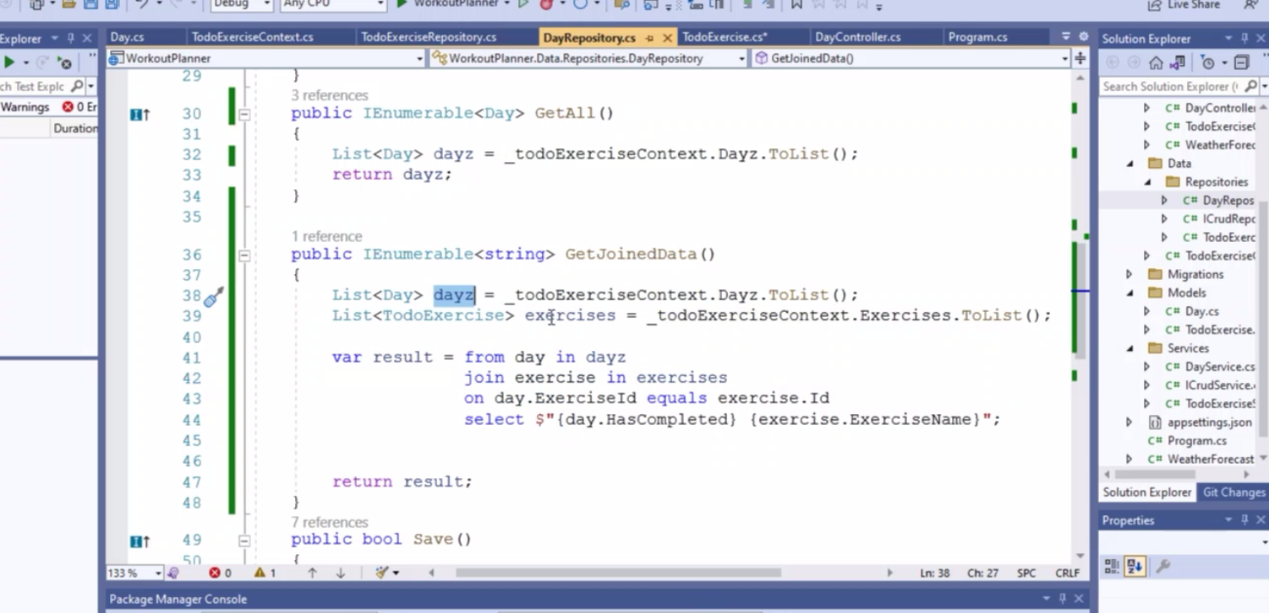

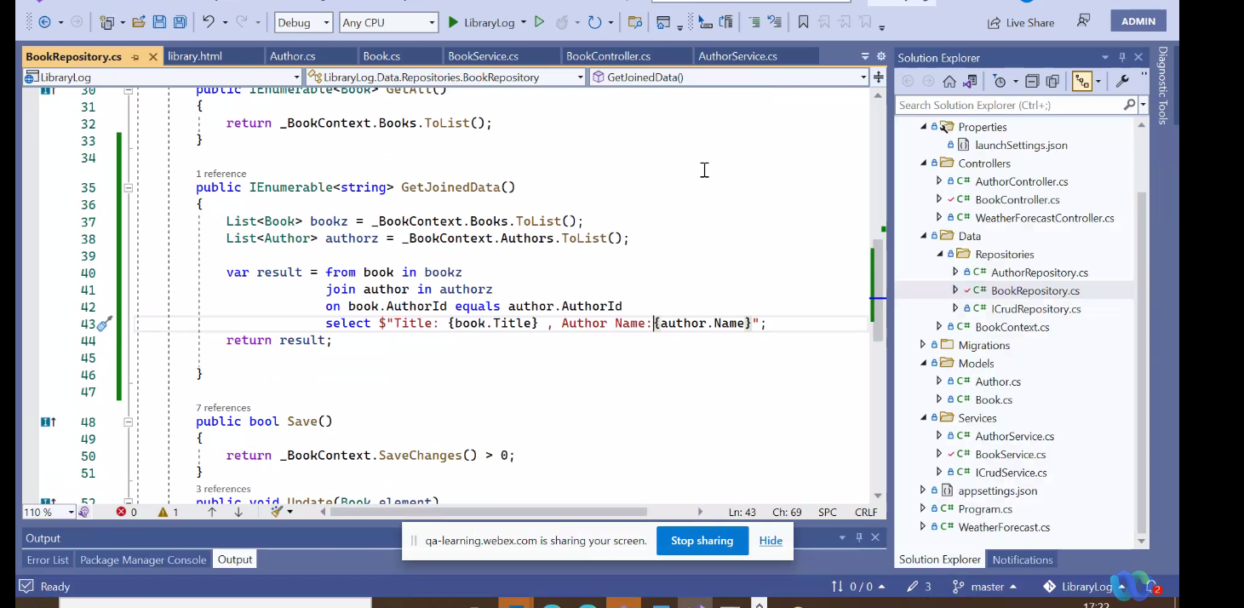

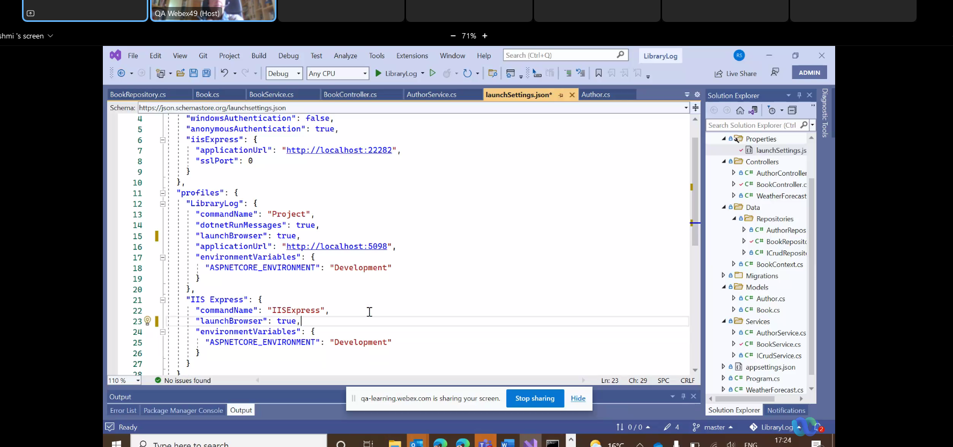

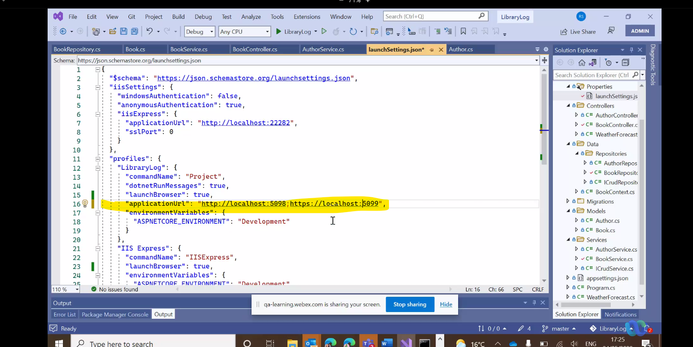remove url swagger

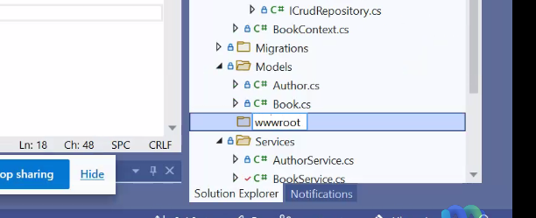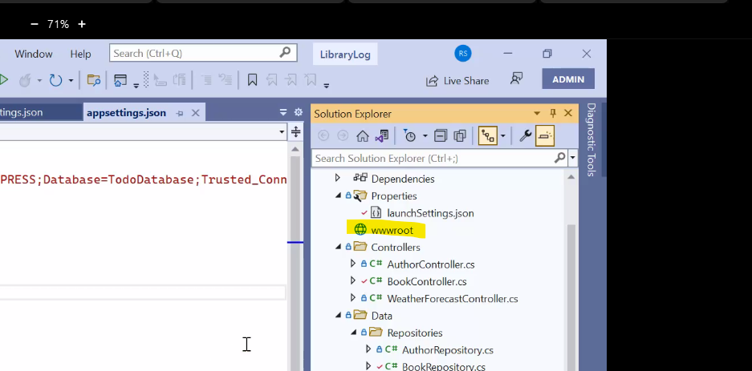

Add new item, html page, call it index.html, add,

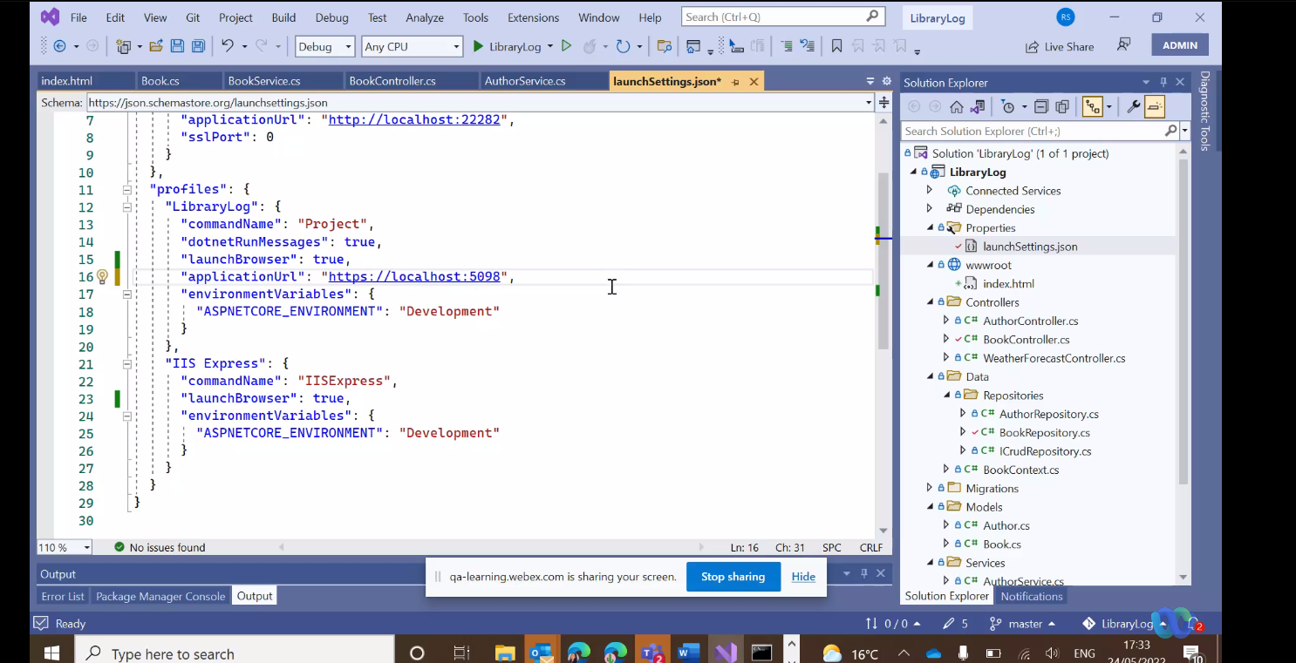

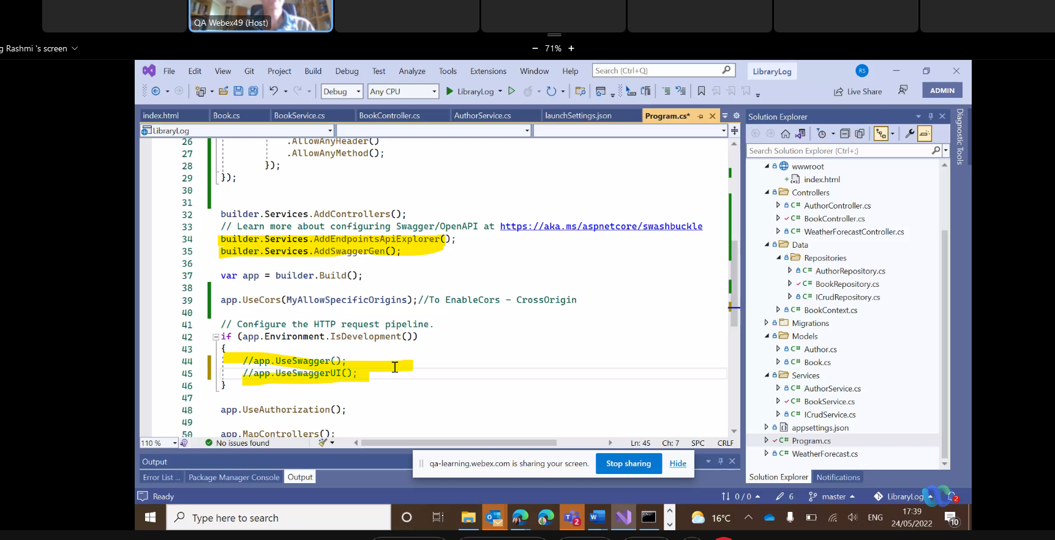

Comment out the yellow stuff

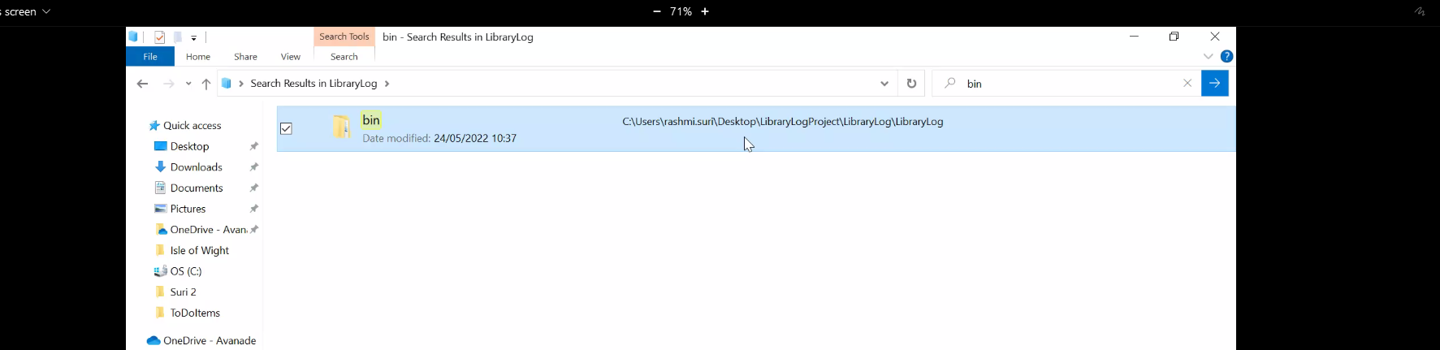delete this

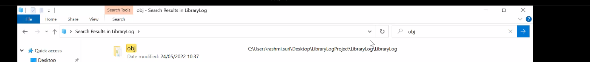

Delete this

Peter.Behague@qa.com